All font is Arial unless otherwise stated.

Sizes of mock ups are approximately the same ratio as actual screen size of webpages when viewed in Google Chrome.

Blue header

Login page

Logo goes here

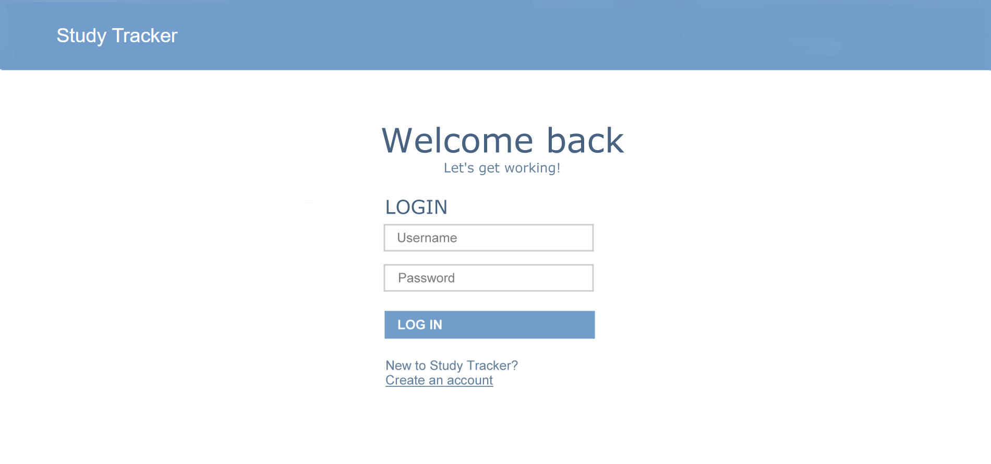

Button redirects users to the main page

White, bolded, medium sized text on a blue button

Navy blue, medium sized, underlined link

Link redirects user to register page

Light grey, medium sized

Text input for password is hidden

Text inputs for username and password, required

Dark navy blue, medium-large sized

Navy blue, medium sized

Dark navy blue, large sized

Register page

Same functions and formatting as the timer page unless otherwise stated

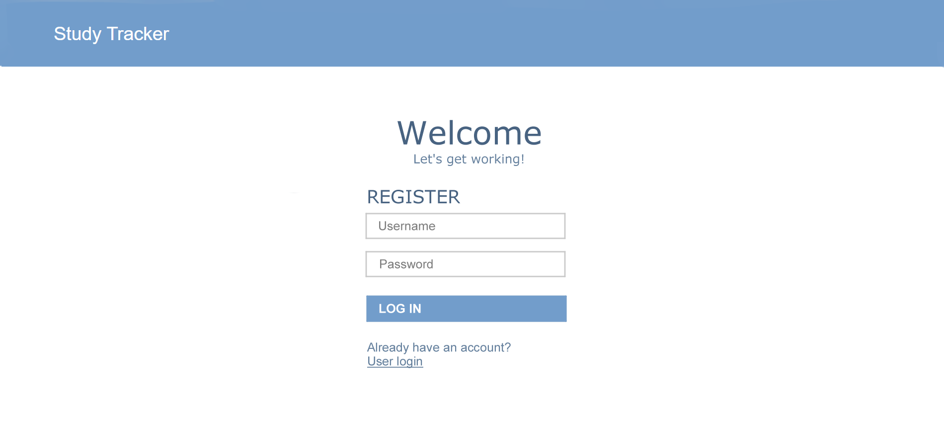

Button creates a new user account and redirects users to the main page

Redirects user to login page

Dark navy blue, large sized

Link that redirects user to the timer page but doesn’t record the length of time for a specific subject/task.

Navy blue, small-medium sized, underlined for link

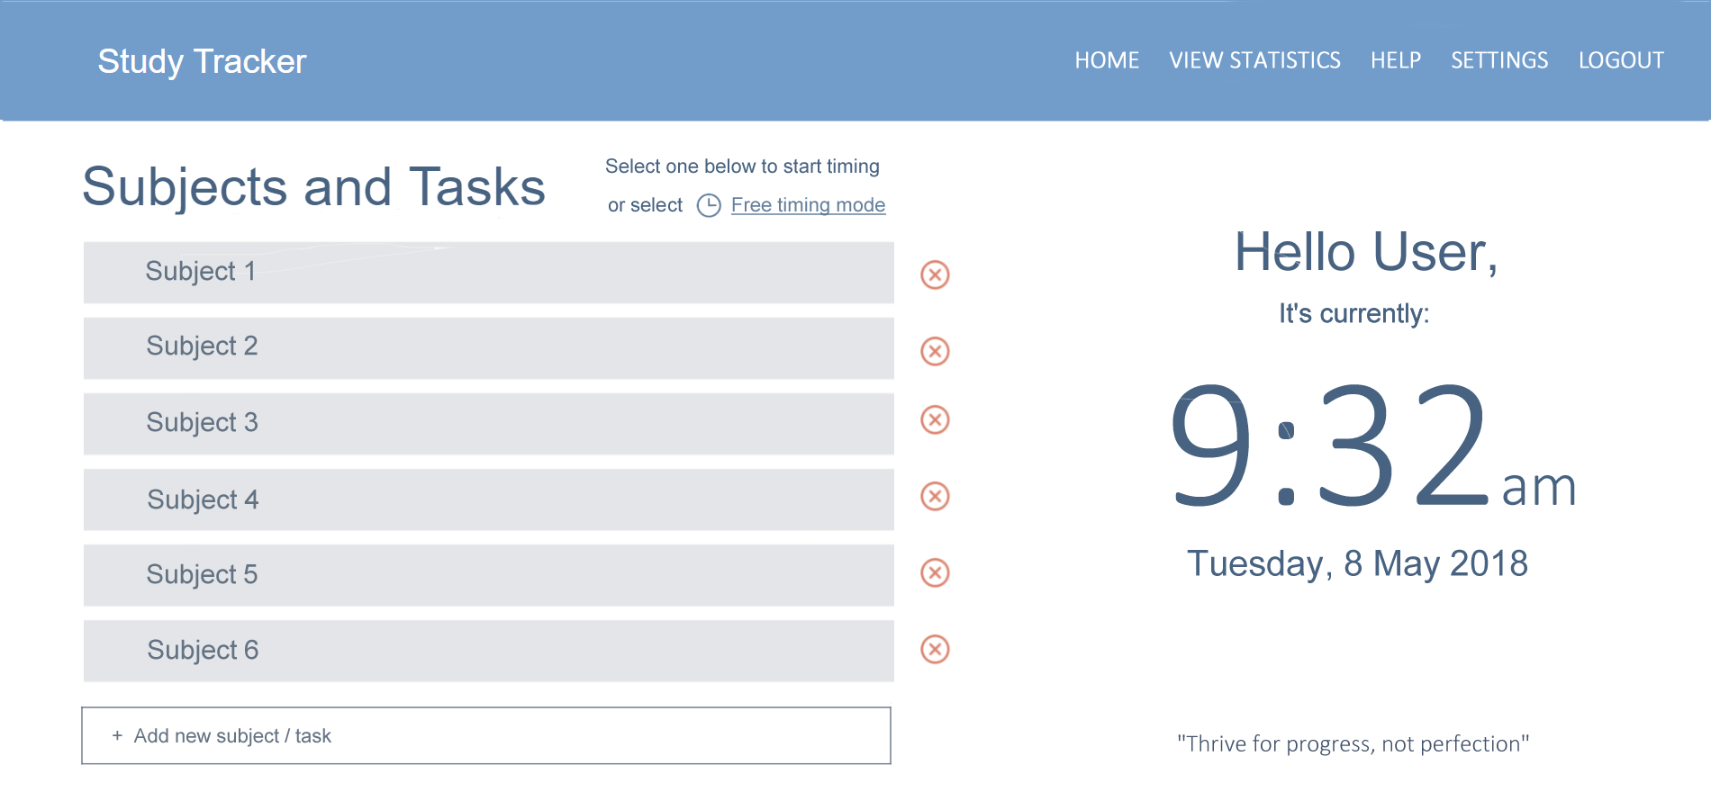

Text input that adds new subjects or tasks to the list

Blue-grey, medium sized text on light grey buttons

Buttons that link to the timer page

Dark navy blue. Calibri Light, extra-large sized for clock and Arial, medium-large sized for date

Functional clock and date

Redirects users to the relevant pages

Calibri Light, white, medium sized

Blue header

User’s name is outputted here

Logo goes here

Buttons to delete a subject/task

Main page

Grey, small sized

Quote

Calibri Light, blue-grey, small sized

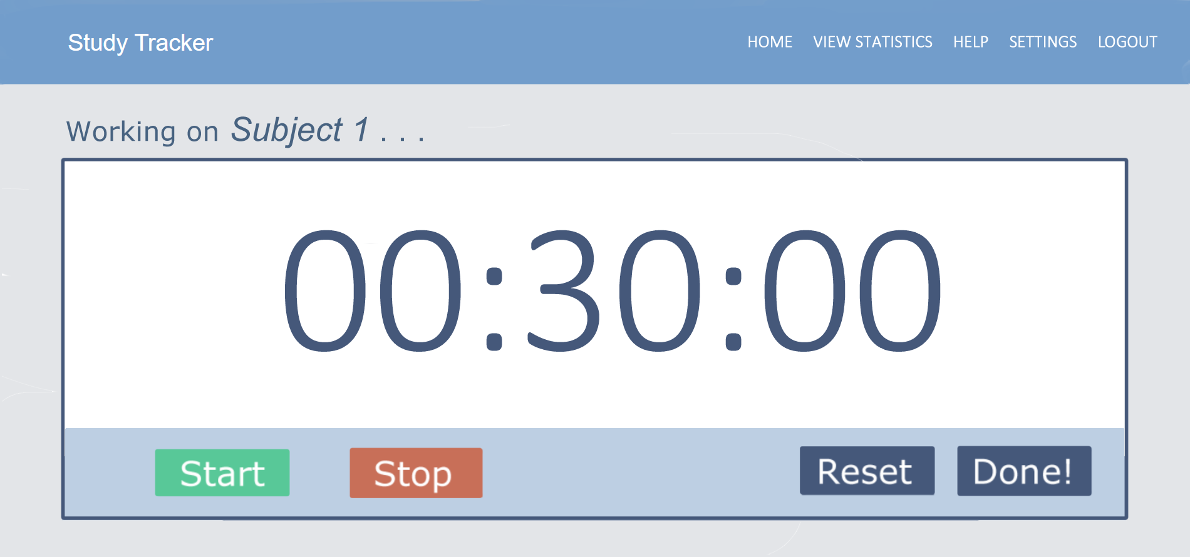

Starts or resumes the timer

White box with thick dark navy blue border

Calibri Light, white, medium sized

Light blue section of white box containing buttons

Dark navy blue, medium-large sized, italicised

Redirects user to the timer done page for user confirmation

Functional timer

Calibri Light, dark navy blue, extra-large sized

Dark navy blue, medium-large sized

Blue header

Selected subject/task name is outputted here

Light grey background

Logo goes here

Timer page

Blue buttons with a navy blue border containing white, medium-large sized text

Green button containing white, medium-large sized text

Pauses the timer

Pauses the timer and resets it back to default value

Red button containing white, medium-large sized text

Same functions and formatting as the timer page unless otherwise stated

Timer length is outputted here

Selected subject/task name is outputted here

Dark navy blue, medium sized, italicized

Timer done page

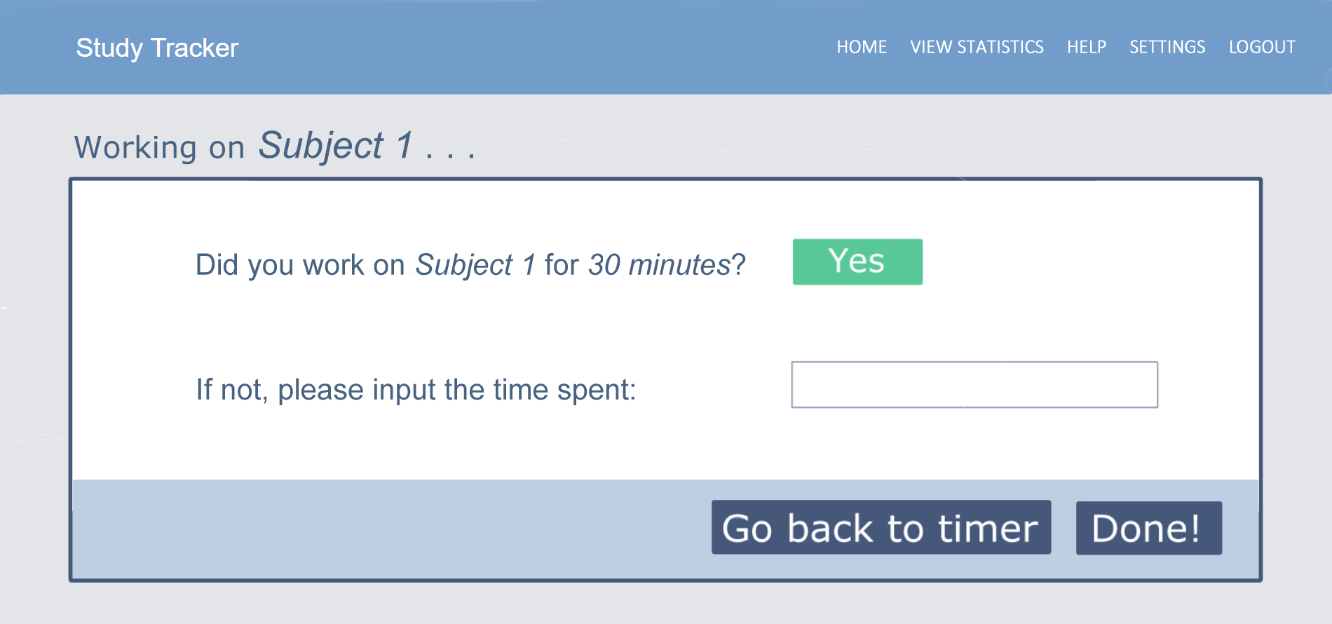

Green button containing white, medium-large sized text

Dark navy blue, medium sized

Saves value specified

Select dropdown list containing numbers in intervals of 5

Redirects back to timer page

Dark navy blue buttons containing white, medium-large sized text

Redirects to main page

Calibri Light, white, small-medium sized

Blue header

Logo goes here

Report (view statistics) page

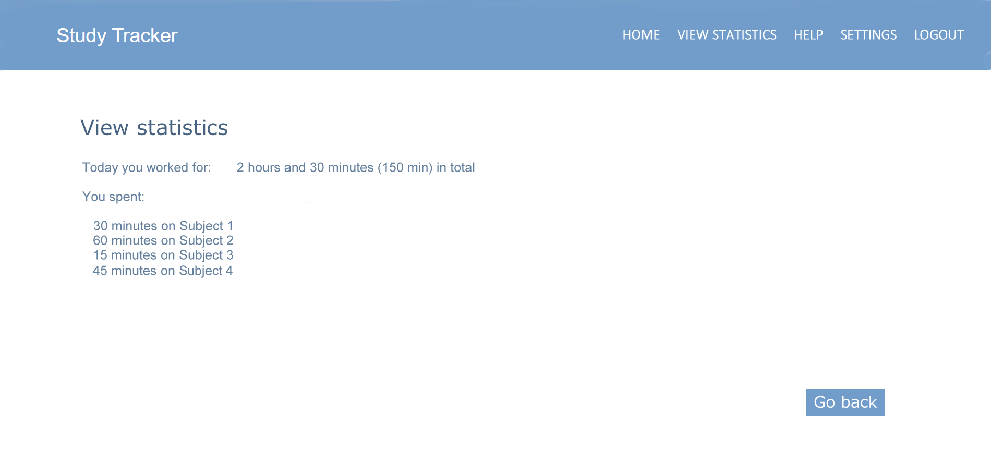

Note: output used in final solution may vary – these are just sample statistics

Navy blue, medium sized

Dark navy blue, medium-large sized

Calculated statistics about the time spent

Redirects user to main page

Blue button containing white, medium sized text

Same functions and formatting as report (view statistics) page unless otherwise stated

Help page

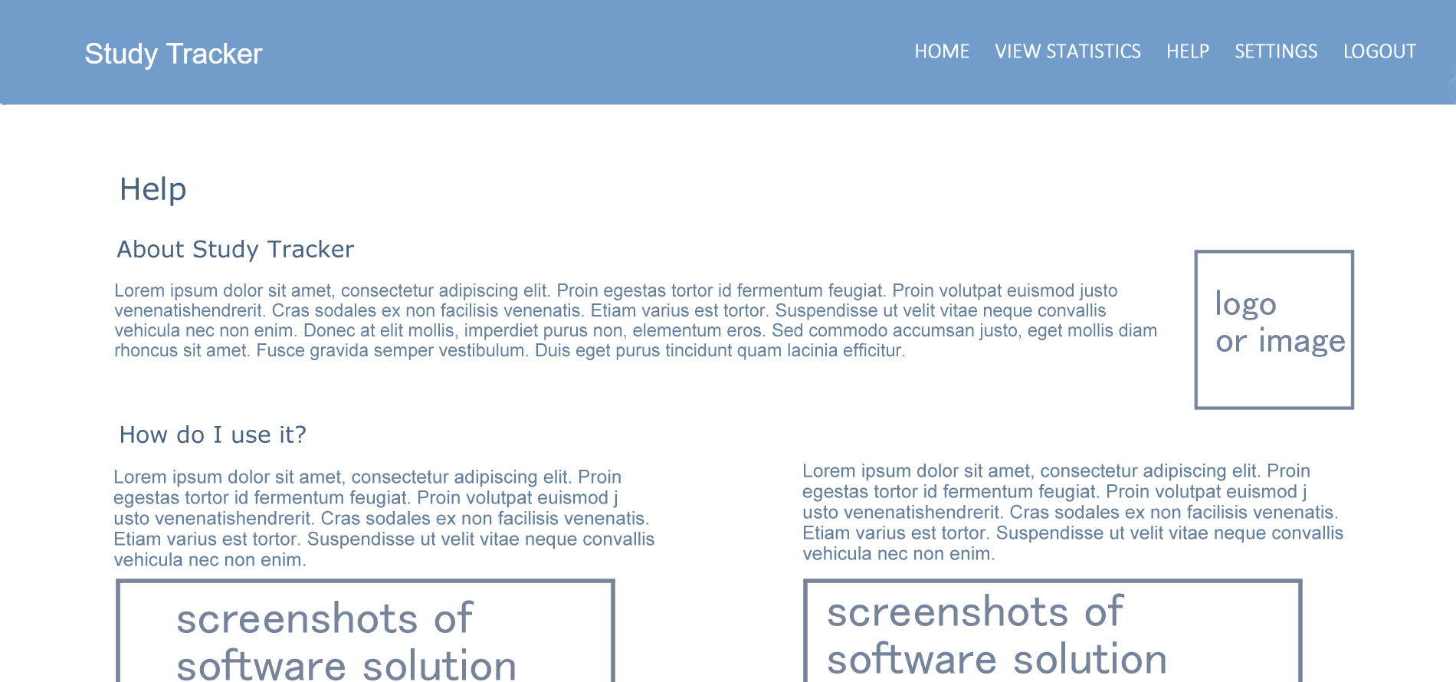

Image of the software’s logo or another relevant image (a timer, books, students etc.)

Note: output and layout used in final solution may vary depending on the final features implemented

Navy blue, medium sized (but slightly smaller than subheadings size)

Dark navy blue, medium sized

Text

Images have a thick navy blue border

Users scroll down for more info

Subheadings

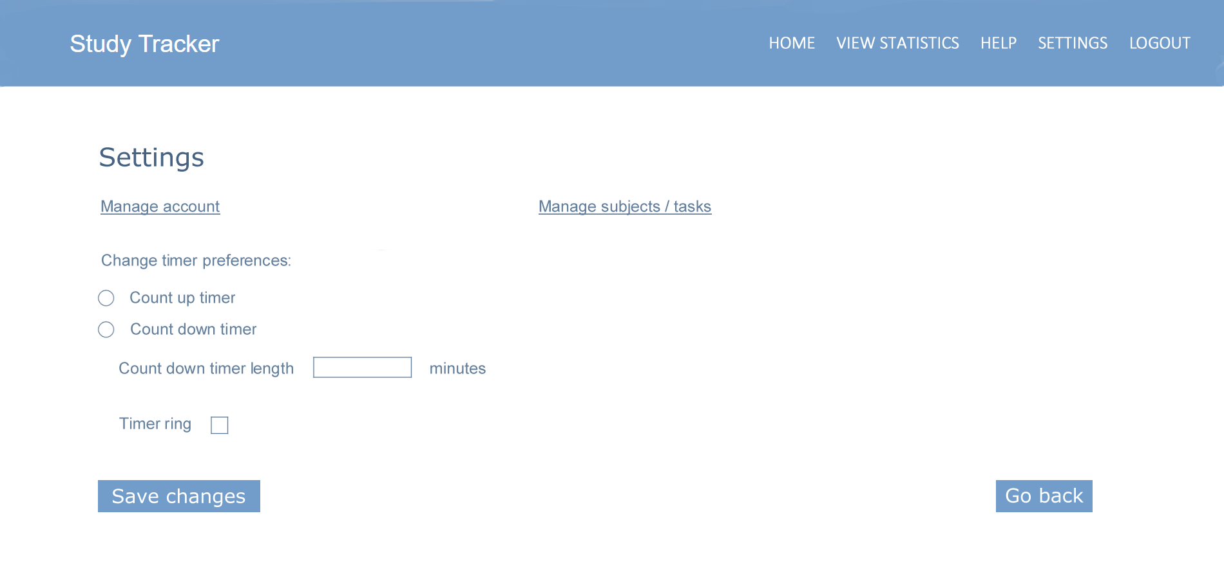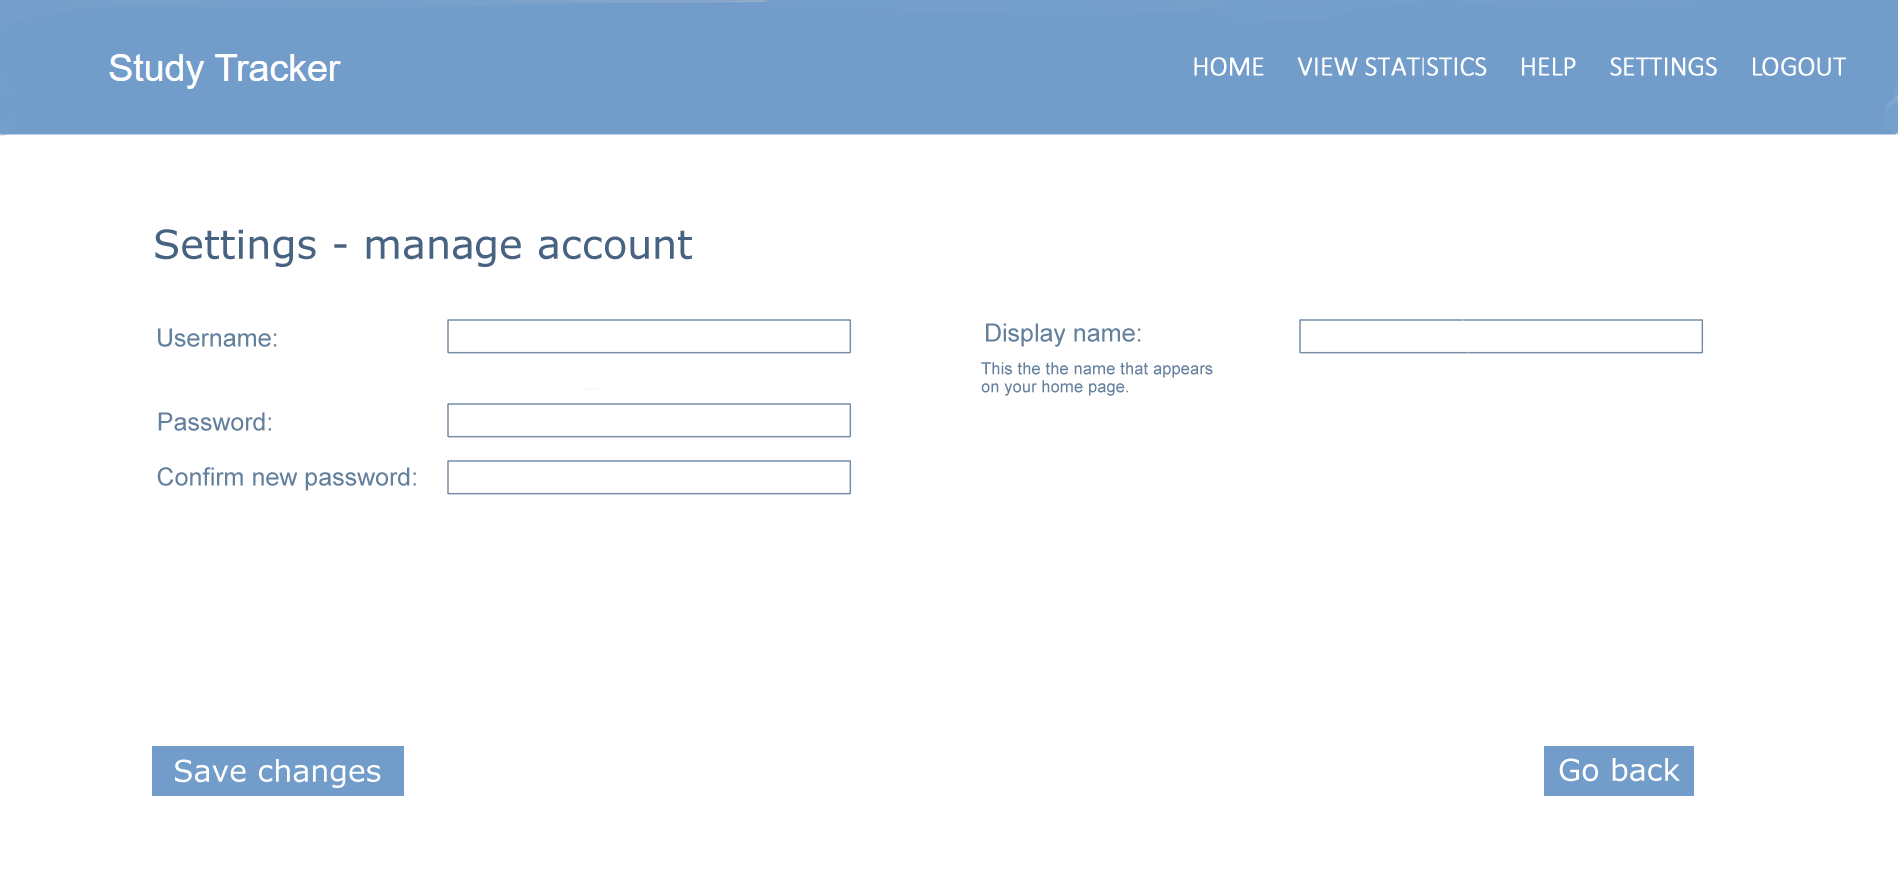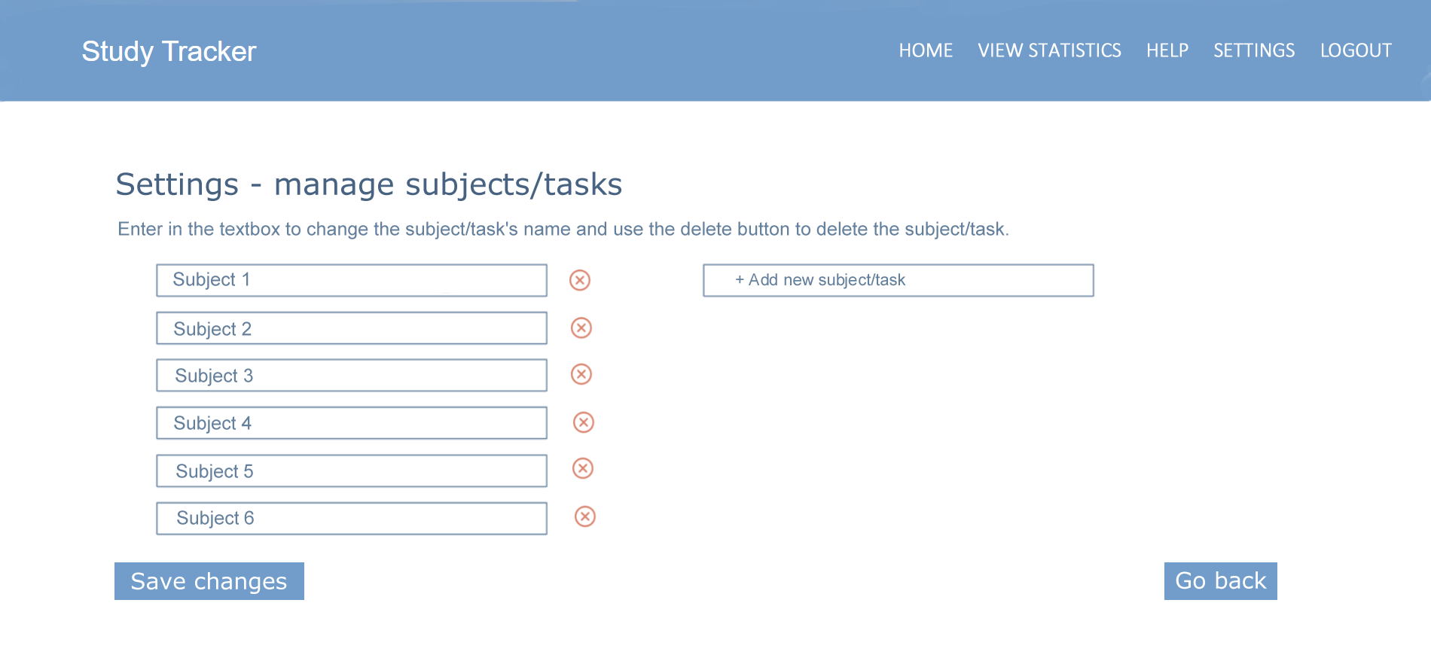

Dark navy blue, medium sized

Navy blue, small text

Text inputs

Text inputs for password are hidden

Links that redirect user to other settings pages (manage account and manage subjects/tasks page) to make changes

Navy blue, medium sized text, underlined

Same functions and formatting as report (view statistics) page unless otherwise stated

Note: output and layout used in final solution may vary depending on the final features implemented

Blue button containing white, medium sized text

Applies changes for the user

Radio buttons to choose between options

Select dropdown list containing numbers in intervals of 5

Checkbox to toggle on/off

Settings page

Redirects user back to settings page

Settings page – manage account

Same functions and formatting as settings page unless otherwise stated

Text input to add in new subject/task

Same functions and formatting as settings – manage account page unless otherwise stated

Buttons to delete subject/task

Text inputs that contain the name of the subject/task

Settings page – manage subjects/tasks